**RESUME**

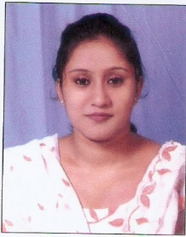

**Monalisha Seth**

Chandannagar, Hooghly

Pin: 712136, West Bengal, India.

**Email : monalisha.sethb@gmail.com**

**Contact no: (+91)** **9681677805**

_________________________________________________________________________________________

#### CAREER OBJECTIVE:

To be a part of an organization where I would get ample opportunity to procure my skill and help the organization in its progress.

**Organizational experience:**

**Dec, 2015-Dec, 2016**

Working in **Realtech Nirman Pvt. Ltd** as **Sales Coordinator.**

**Job Profile:**

* Coordinate sales team by managing schedules, filing important documents and communicating relevant information.
* Ensure the adequacy of sales-related equipment or material.
* Respond to complaints from customers and give after-sales support when requested.
* Store and sort financial and non-financial data in electronic form and present reports.
* Handle the processing of all orders with accuracy and timeliness.
* Inform clients of unforeseen delays or problems.
* Monitor the team’s progress, identify shortcomings and propose improvements.
* Assist in the preparation and organizing of promotional material or events.
* Ensure adherence to laws and policies.

**Educational Qualifications:**

* Passed **MBA** in **Marketing** form **Sikkim Manipal University** in the year **2014** with a **60%**
* Passed **BA** form **Burdwan University** in the year **2011** with a **46%**
* Passed **10+2th** from **W.B.C.H.S.E** in the year **2008** with a **56%.**
* Passed **10th**from **W.B.B.S.E** in the year **2006** with a **50%.**

## **TECHNICAL SKILLS:**

* Operating Systems **:** Windows XP, 2007, 2008.
* Microsoft Office **:** 2007, 2010

## **PERSONAL SKILLS:**

Willingness to work in team and hard worker, Ability to work under pressure and meet deadline, Disciplined & good etiquette, Productive working relationships with clients & staff.

**PERSONAL PROFILE:**

Father’s Name **:** Nimai Chandra Seth.

Nationality **:** Indian

Date of Birth **:** 11/ 04/ 1991

Hobbies **:** Social Networking Listening Music & Cooking.

Languages Known **:**  Bengali, English and Hindi

Permanent Address : Chandannagar, Hooghly, Pin: 712136, West Bengal, India.

**DECLARATION:**

I hereby declare that the above mentioned particulars are true to the best of my knowledge and belief.

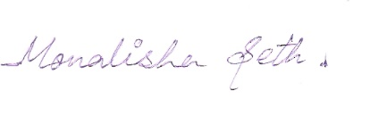

**Date: ---------------------------------**

**Place: Kolkata (Monalisha Seth)**